Infinitive Phrases as Modifiers

🔹 What Is Infinitive Phrases as Modifiers?
# Source: AI Source: Provided by: [Data Path: Persons Table -> ID Column: 1, Name_En Column: Motasem Essam] -> From: [Chatgpt (GPT‑5 Mini)] on [8/7/2025]
An infinitive phrase is a group of words beginning with "to" + base verb that acts as a modifier, describing or giving more information about a noun, pronoun, or verb.

🔸 Structure:
# Source: AI Source: Provided by: [Data Path: Persons Table -> ID Column: 1, Name_En Column: Motasem Essam] -> From: [Chatgpt (GPT‑5 Mini)] on [8/7/2025]
to + base verb + (modifiers and/or objects)

Examples:
- to win the game
- to make her happy
- to study grammar hard

🔸 Functions of Infinitive Phrases as Modifiers:
# Source: AI Source: Provided by: [Data Path: Persons Table -> ID Column: 1, Name_En Column: Motasem Essam] -> From: [Chatgpt (GPT‑5 Mini)] on [8/7/2025]
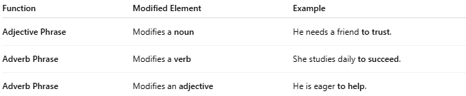
Function | Modified Element | Example
Adjective Phrase | Modifies a noun | He needs a friend to trust.
Adverb Phrase | Modifies a verb | She studies daily to succeed.
Adverb Phrase | Modifies an adjective | He is eager to help.

🔸 Examples in Sentences:
# Source: AI Source: Provided by: [Data Path: Persons Table -> ID Column: 1, Name_En Column: Motasem Essam] -> From: [Chatgpt (GPT‑5 Mini)] on [8/7/2025]
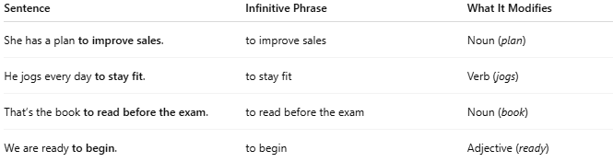
Sentence | Infinitive Phrase | What It Modifies
She has a plan to improve sales. | to improve sales | Noun (plan)
He jogs every day to stay fit. | to stay fit | Verb (jogs)
That’s the book to read before the exam. | to read before the exam | Noun (book)
We are ready to begin. | to begin | Adjective (ready)

